EXLORATIVE WALK name: ………….…………………… Date and Time: ……………… Walk leader: ……………..………..
Participant: ……………………………………………………………… University: ……………………………………………………….………
Academic course: …………………………………………………………………….. Role: ………………………………………………..………..
Permanent or temporary disability or impairment (Y/N) .......................Type: ………………………………………………..
Main aim of the explorative walk: ……………………………………………………………………………………………………..…….…..

ROUTE N./NODE N. …………… Short description: …………………………………………………………………………………………

Functions of the urban environment (yes or no/* specification)
Residential | Commercial | Public services | Cultural functions (theatre, cine, libraries) | Greenspaces | Health care | Other *

Urban features (yes or no/* specification)
Roads* (main, local, pedestrian) | Public transport features *(transit stops, lanes) | Parking areas | Squares and green areas | Pedestrian areas | Unbuilt areas | Other*

Urban elements/items (yes or no/* specification)
Sidewalks | Staircases, overpasses, tunnels* | Urban furnishing* (benches, lighting, decorative items, fences) | Urban signals and signboards | Kiosks and dehors | Trees and flower beds | Other*

Type and number of barriers (yes or no/* specification)
Absent or not adequate sidewalks or other walkable spaces | traffic congestion and lack of parking spaces | Obstacle caused by urban items | Other lacks or difficulties in access to public and private spaces*

.………………………………………………………………………………………………………………………………………………………………………
……………………………………………………………………………………………………………………………………………………………………….

Overall accessibility rate (0 to 5):
Walking | Biking | Children | elders | wheelchair | blind | Other  -

- Symptoms of crisis phenomena in the area: ………………………………………………..……………………………………....……
………………………………………………………………………………………………………………………………………………………………….
- Potential stakeholders (to be involved to support possible projects): ……………………………………………………….
………………………………………………………………………………………..………………………………………………………………………..
- Proposals of interventions to improve accessibility: …………………………………………………………………………………………….……………………………………………………………………
………………………………………………………………………………………………………………………………………………………………….………………………………………………………………………………………………………………………………………………………………….

ROUTE N./NODE N. …………… Short description: …………………………………………………………………………………………

Functions of the urban environment (yes or no/* specification)
Residential | Commercial | Public services | Cultural functions (theatre, cine, libraries) | Greenspaces | Health care | Other *

Urban features (yes or no/* specification)
Roads* (main, local, pedestrian) | Public transport features *(transit stops, lanes) | Parking areas | Squares and green areas | Pedestrian areas | Unbuilt areas | Other*

Urban elements/items (yes or no/* specification)
Sidewalks | Staircases, overpasses, tunnels* | Urban furnishing* (benches, lighting, decorative items, fences) | Urban signals and signboards | Kiosks and dehors | Trees and flower beds | Other*

Type and number of barriers (yes or no/* specification)
Absent or not adequate sidewalks or other walkable spaces | traffic congestion and lack of parking spaces | Obstacle caused by urban items | Other lacks or difficulties in access to public and private spaces*

.………………………………………………………………………………………………………………………………………………………………………
……………………………………………………………………………………………………………………………………………………………………….

Overall accessibility rate (0 to 5):
Walking | Biking | Children | elders | wheelchair | blind | Other  -

- Symptoms of crisis phenomena in the area: ………………………………………………..……………………………………....……
………………………………………………………………………………………………………………………………………………………………….
- Potential stakeholders (to be involved to support possible projects): ……………………………………………………….
………………………………………………………………………………………..………………………………………………………………………..
- Proposals of interventions to improve accessibility: …………………………………………………………………………………………….……………………………………………………………………
………………………………………………………………………………………………………………………………………………………………….………………………………………………………………………………………………………………………………………………………………….

ROUTE N./NODE N. …………… Short description: …………………………………………………………………………………………

Functions of the urban environment (yes or no/* specification)
Residential | Commercial | Public services | Cultural functions (theatre, cine, libraries) | Greenspaces | Health care | Other *

Urban features (yes or no/* specification)
Roads* (main, local, pedestrian) | Public transport features *(transit stops, lanes) | Parking areas | Squares and green areas | Pedestrian areas | Unbuilt areas | Other*

Urban elements/items (yes or no/* specification)
Sidewalks | Staircases, overpasses, tunnels* | Urban furnishing* (benches, lighting, decorative items, fences) | Urban signals and signboards | Kiosks and dehors | Trees and flower beds | Other*

Type and number of barriers (yes or no/* specification)
Absent or not adequate sidewalks or other walkable spaces | traffic congestion and lack of parking spaces | Obstacle caused by urban items | Other lacks or difficulties in access to public and private spaces*

.………………………………………………………………………………………………………………………………………………………………………
……………………………………………………………………………………………………………………………………………………………………….

Overall accessibility rate (0 to 5):
Walking | Biking | Children | elders | wheelchair | blind | Other  -

- Symptoms of crisis phenomena in the area: ………………………………………………..……………………………………....……
………………………………………………………………………………………………………………………………………………………………….
- Potential stakeholders (to be involved to support possible projects): ……………………………………………………….
………………………………………………………………………………………..………………………………………………………………………..
- Proposals of interventions to improve accessibility: …………………………………………………………………………………………….……………………………………………………………………
………………………………………………………………………………………………………………………………………………………………….………………………………………………………………………………………………………………………………………………………………….

Put here the map with the routes and node of the explorative walk. See example below
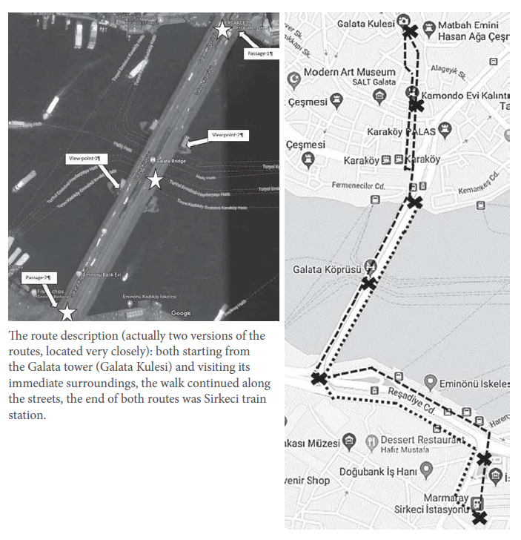

Final discussion at the end of the explorative walk

Recommendation for future explorative walks: …………………………………………………………………………………………….
………………………………………………………………………………………………………………………………………………………………………………………………………………………………………………………………………………………………………………………………………………………………………………………………………………………………………………………………………………………………………………………………………………………………………………………………………………………………………………………………………………………………………………………………………………………………………………………………………………………………………………………………………………………………………………………………………………………………………………………………………………………………………………

How did you evaluate the adopted service-learning approach (0-5)? Please include some considerations: ………………………………………………………………………………………………………………………………………………………………………………………………………………………………………………………………………………………………………………………………………………………………………………………………………………………………………………………………………………………………………………………………………………………………………………………………………………………………………………………………………………………………

How was the use of digital and printed maps? ………………………………………………………………………………………………
………………………………………………………………………………………………………………………………………………………………………………………………………………………………………………………………………………………………………………………………………………
………………………………………………………………………………………………………………………………………………………………………………………………………………………………………………………………………………………………………………………………………………

Final considerations about the study case accessibility and recommendations for accessibility improvement:
………………………………………………………………………………………………………………………………………………………………………
………………………………………………………………………………………………………………………………………………………………………………………………………………………………………………………………………………………………………………………………………………
………………………………………………………………………………………………………………………………………………………………………
………………………………………………………………………………………………………………………………………………………………………………………………………………………………………………………………………………………………………………………………………………
………………………………………………………………………………………………………………………………………………………………………
………………………………………………………………………………………………………………………………………………………………………………………………………………………………………………………………………………………………………………………………………………

